Lab Task 11
Talal Ali 24k0863

TASK 01:
#include <iostream>
using namespace std;
class CloseHashingTable {
int table[7];

int hashfunc(int key) {
return key % 7;
}

public:
CloseHashingTable() {
for (int i = 0; i < 7; i++)
table[i] = 0;
}

void insert(int key) {
int index = hashfunc(key);

// Linear probing
int start = index;
while (table[index] != 0) {
index = (index + 1) % 7;
if (index == start) {
cout << "Hash table full\n";
return;
}
}
table[index] = key;
}

void display() {
cout << "\nClosed Hash Table (Linear Probing):\n";
for (int i = 0; i < 7; i++)
cout << i << ": " << table[i] << endl;
}
};
class Node {
public:
int data;
Node* next;
Node(int d) : data(d), next(nullptr) {}
};

class OpenHashingTable {
Node* table[7];

int hashfunc(int key) {
return key % 7;
}

public:
OpenHashingTable() {
for (int i = 0; i < 7; i++)
table[i] = nullptr;
}

void insert(int key) {
int index = hashfunc(key);
Node* newNode = new Node(key);

if (table[index] == nullptr) {
table[index] = newNode;
} else {
newNode->next = table[index];
table[index] = newNode;
}
}

void display() {
cout << "\nOpen Hash Table (Separate Chaining):\n";
for (int i = 0; i < 7; i++) {
cout << i << ": ";
Node* temp = table[i];
while (temp) {
cout << temp->data << " -> ";
temp = temp->next;
}
cout << "NULL\n";
}
}
};

int main() {
int keys[] = {76, 93, 40, 47, 10, 55};

CloseHashingTable closed;
OpenHashingTable open;

for (int k : keys) {
closed.insert(k);
open.insert(k);
}

closed.display();
open.display();

return 0;
}

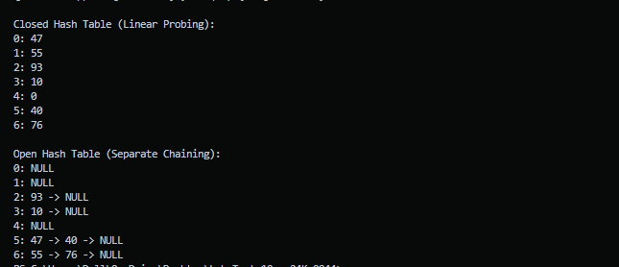

QUESTION 02:
- Load Factor = Number of Elements / current size
= 75 / 100
= 0.75
Since the load factor calculated matches the threshold value, so the system will trigger rehashing.
- Double the size of the current size, so now the new size would be = 100 * 2 = 200

To create new table do following:
- Create a new table with the new size and initialize all the entries empty.
- For each key, recalculate its hashing value and insert in the table using same collision-handling method.
- Finally replace the old table by this new table.

Question 03:
- Core steps of brute force algorithm:
- Align P with T starting at index i = 0.
- Compare characters of P with T from left to right.
- If all character matches, report the index.
- If a mismatch occurs shift the window by 1 to the right.

Tracing the first two comparisons.
T: G C A A T G C ...
P: T A T G T
At index = 0, T[i] != P[i], mismatch so shift the window by 1 to right.
T: C A A T G C ...
P: T A T G T
At index = 0, T[i[ != P[i[, mismatch.
- Boyer-Moore:
Index: 3 4 5 6 7 8
Text: A T G C C T ...
Pattern: T A T G T
^ mismatch at P[4] vs T[7]='C'
Mismatch occurs at:
- Pattern position j = 4 (P[4] = 'T')
- Text character 'C' is the Bad Character

Bad Character Heuristic (Case 2): Shift Past the Bad Character
The rule:
$$\text{Shift}=j-\text{lastOccur}(\text{badChar})$$
Where:
$j=4$(mismatch position)
lastOccur('C') = –1 (since 'C' is not in the pattern)
So:
$$\text{Shift}=4-(-1)=5$$shift = 5 position

Since 'C' does not appear anywhere in the pattern, there is no reason to keep the pattern anywhere near the current text position.
The pattern must move completely past the mismatch position in the text, which requires a shift equal to the full length of the pattern:
Pattern length = 5 → shift 5.
Thus Boyer–Moore jumps far ahead because matching at this position is impossible.

Question 04:
- LPS Array Construction for P = "ABABA"
Index: 0 1 2 3 4
P: A B A B A
LPS: 0 0 1 2 3

LPS[4] = 3 means:
For the substring P[0..4] = "ABABA",
the longest proper prefix that is also a suffix has length 3, which corresponds to "ABA".
In KMP, this value tells us:
- If a mismatch occurs after matching the entire pattern up to index 4,
- We do not restart at the beginning.
- Instead, we shift the pattern so that the prefix "ABA" is aligned with the suffix "ABA",
- and resume comparison from P[3].
This is the essence of KMP's efficiency.

- KMP resumes comparison from pattern index 3.

